# Global Economic and Demographic Trends Analysis

# Project Overview

## This project analyzes global economic and demographic trends using diverse datasets covering population, GDP, life expectancy, literacy rates, and other socio-economic indicators. By examining these factors across countries and regions over several decades, it uncovers key patterns and correlations that reveal how economies and populations have evolved. The insights gained offer valuable context for understanding past trends and support future forecasting, benefiting policymakers, economists, researchers, and planners.

## Dataset Description

* Datasets
  + Countries World - SQL
  + GDP-(1960 – 2016) – XML - Excel
  + Population Per Country – CSV – Excel
  + Meta Country – CSV - Excel
* Key Features
* Country-wise economic and demographic data.
* Time range covering several decades (1960-2016).
* Key metrics include:
  + GDP per capita
  + Population growth rates
  + Life expectancy
  + Urbanization rates
  + Literacy rates

## Data Cleaning Process

To ensure data quality, several cleaning steps were performed:

* **Excel Cleaning:** Performed initial data cleaning by organizing raw data.
* **Power BI Power Query Cleaning:** Applied advanced cleaning and transformation techniques.
* **Handled Missing Values:** Replaced or removed missing data to ensure data consistency.
* **Removed Blank Rows and Duplicates:** Eliminated unnecessary rows and duplicate entries.
* **Changed Correct Data Format & Data Types:** Standardized data formats and types for accuracy.
* **Transformed the Data Table:** Restructured data tables for better analysis and visualization.

## Descriptive Statistical Analysis

Basic descriptive statistics were used to summarize and understand the data, including:

* Mean, median, and mode for key indicators.
* Distribution analysis for GDP, life expectancy, and population growth.
* Identification of trends and outliers over the decades.

## DAX Calculations

Custom DAX calculations were applied in Power BI (or equivalent tools) for:

1. **Average GDP Per Capita**

Calculates the average GDP per capita across countries.

1. **GDP Growth Rate (%)**

Computes the average GDP growth rate in percentage.

1. **Total GDP Value**

Aggregates the total GDP value across all regions.

1. **GDP Growth Rate by Year**

Calculates the average GDP growth rate for each year.

1. **Mean Population**

Determines the average mean population across countries.

1. **Median Population**

Returns the middle population value when sorted.

1. **Mode Population**

Identifies the most frequently occurring population value.

1. **Population Growth Rate (%)**

Calculates the average population growth rate in percentage.

1. **Standard Deviation of Population**

Measures the spread of population values from the mean.

1. **Total GDP by Region**

Summarizes the total GDP value by region.

1. **Yearly GDP Calculation**

Computes the total GDP value for each year.

## Dashboard Description

**Dashboard 1: Global Overview**

* Visualized GDP growth over time.
* Regional comparisons for life expectancy and infant mortality.
* Population Distribution by Income Group.

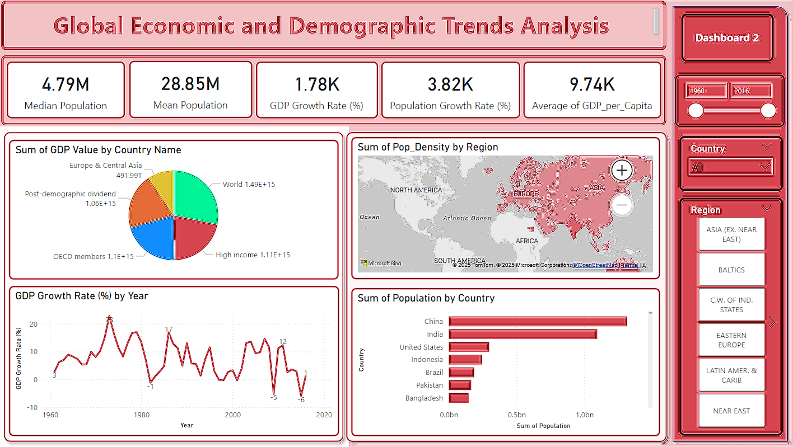

**Dashboard 2: Country-Specific Insights**

* GDP per capita trends by Country
* Population density and urbanization trends by region.
* Agriculture vs Industry vs Service by Country

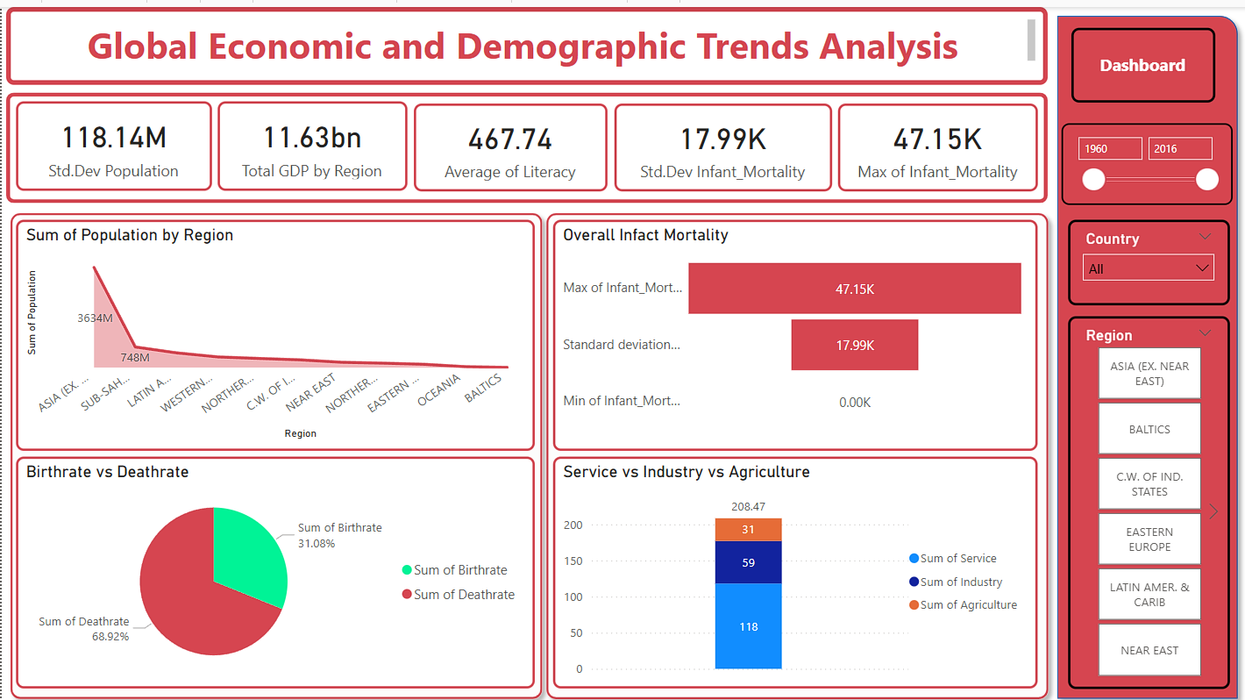

**Insights**

**1. Economic Disparities and Demographics**

* Countries with **higher GDP per capita** generally exhibit **lower infant mortality rates**, indicating a positive relationship between economic development and healthcare infrastructure.

**Regional Variations:**

* Developed regions tend to have **lower birth and death rates**, along with **higher GDP** and **service sector dominance**.
* Developing regions rely heavily on **agriculture** and **industry**, with higher birthrates and lower GDP.

**3. Demographic Transition Trends**

* Europe’s low birth and high death rates indicate aging populations, raising healthcare and pension challenges.
* High birthrate countries (e.g., Cambodia) are in early demographic transition, leading to a young, growing workforce.

**4. Income Group Trends**

* Lower and upper middle-income groups dominate, highlighting economic gaps and limited upward mobility opportunities.
* Economic policies need to focus on education, financial access, and social safety nets.

**5. Healthcare and Quality of Life:**

* Regions with **lower literacy rates** and **higher infant mortality rates** consistently show **lower GDP** values, emphasizing the importance of **education and healthcare investment** in overall development

**Recommendations**

**1. Healthcare Investments**

* Improve maternal and infant health programs in low-GDP countries.
* Enhance public health systems in high-density regions to prevent disease outbreaks.

**2. Education and Literacy Initiatives**

* Increase education funding, especially in low-income areas.
* Provide scholarships and vocational training to improve workforce quality.

**3. Urban Planning in High-Density Areas**

* Promote smart city development to address housing, transport, and environmental issues.
* Implement population management strategies for balanced urban growth.

**4. Economic Diversification**

* Develop infrastructure (roads, ports, power) in low-income regions.
* Encourage foreign direct investment (FDI) and support agriculture, tech, and renewable energy sectors.

## Conclusion

This analysis offers crucial insights into the long-term evolution of global economies and population dynamics, highlighting key shifts in economic performance, demographic transitions, and social development over time. By identifying these trends, the analysis helps policymakers, economists, and researchers gain a deeper understanding of the historical context behind current global conditions. These insights also serve as a valuable foundation for anticipating future changes, enabling data-driven decision-making and the development of informed strategies to address emerging economic and demographic challenges.